

**Name:** Md. Rifat Ahmed

**ID:** 1931725042

**Course:** CSE311

**Section:** 9

# ASSIGNMENT ON

Cascade Operations

## **Submitted To:** Nadeem Ahmed

**CASCADE OPERATIONS:** There are two types of Cascade operations one is ON DELETE CASCADE and another one is ON UPDATE CASCADE.

**ON DELETE CASCADE:** When we create a foreign key using ON DELETE CASCADE and then delete any record from the parent table then the referencing records in the child table will also be deleted.

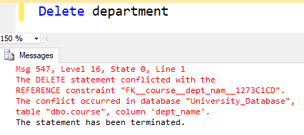

Here we tried to delete the records of department table that has multiple child tables but we couldn’t delete them because we had not used any CASCADE operations while creating the child tables that’s why the foreign keys from those child table were conflicting with it.

But now if we create the child tables using ON DELETE CASCADE and delete the records of department table here’s what happens,

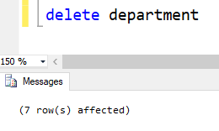

We successfully manage to delete the records of department table.

Before deleting the records from department table here’s how the records from it and its child tables looked like,

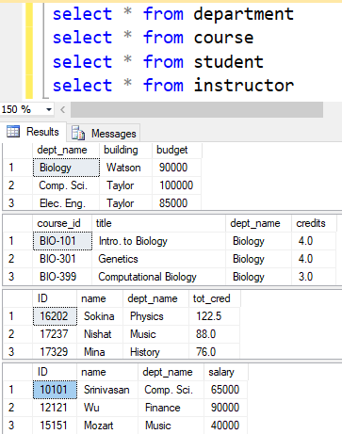

But after deleting records from department table the referencing records from its child tables were also deleted along with them.

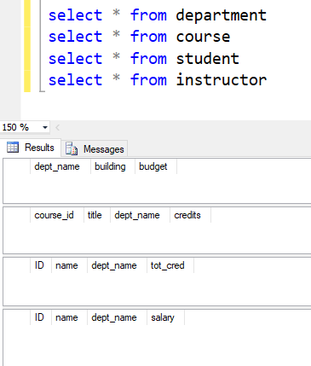

**ON UPDATE CASCADE**: When we create a foreign key using ON UPDATE CASCADE and then update any record at the parent table then the referencing rows in the child table also gets updated with them.

After creating the child tables using ON UPDATE CASCADE here’s how the tables looked like before updating the department table,

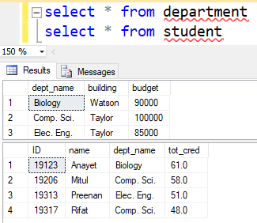

But after we updated the dept_name in the parent table from ‘Comp. Sci.’ to ‘CSE’ the dept_name in the child tables were also updated.

